

UWI

INFO3410
WEB SYSTEMS AND TECHNOLOGIES

Group Members ID Numbers

THAYNE DAVIS-SAMPSON 810004250

DOMINIC HINDS 814004951

AFDAL KHAN 815009688

DANEILIA LEWIS 815009098

NIRMAL RAMKISSOON 813000507

Table of contents
Section 1- Introduction………………………………………………………………………………………1

Section 2- Background……………………………………………………………………………………….1

Section 3- Architecture……………………………………………………………………………………….2

Section 4- Results ……………………………………………………………………………………………3

Section 5-Conclusion & Future work…………………………………………………………………………8

INTRODUCTION
The Department of Computing and Information Technology (DCIT) realizes the importance of keeping in touch with its past graduates. This will enable the department to have a better understanding of placement of graduates and the ICT-related needs of society. This will connect the department to a network of skilled local professionals to help accomplish the many roles and responsibilities that exist within the department. Therefore, the department requires the development of a web-based database to allow past graduates of the department of Computing and Information Technology to upload and update information about their employment and interests.

This paper will discuss the tools and technologies used to implement the proposed solution, a diagram of how the proposed solution should work, screenshots of the working application and future improvements on it.

BACKGROUND
The department of Computing and Information Technology has no centralized database for past graduates and linkages with alumni. The campus has a very restrictive website policy which prevents departments from having database driven applications hosted on the UWI network.
The proposed solution to this problem is to create and centralized database hosted outside of UWI network.

ARCHITECTURE

Heroku – This is a cloud platform as a service (PaaS) that supports several languages. It is used as a web application development model. It lets developers build scale and run applications across all languages. It was used to host the web application made.


ClearDB – It is a cloud, hybrid, and on premise database-as-a-service for MySQL powered applications. It stores and manages your MySQL database for you so that you don’t have to deal with things such as database servers, replication, storage, database failures etc. It was used to make the database which was then used in the application build.


Bootstrap – this was used to do all the CSS styling. Bootstrap is a free and open source front-end web framework for designing websites and web applications. It contains HTML and CSS based design templates.


SLIM – this is the framework that was used to do build the web application. Slim is a PHP micro framework that helps you write simple but powerful web applications and APIs. Slim is a dispatcher that receives an HTTP request and invokes the appropriate callback routine and returns a HTTP response.


GITHUB - A repository was created to allow the developers to upload completed tasks to a centralized platform. The repository will then be linked to Heroku so that the website can be easily launched from the repository.

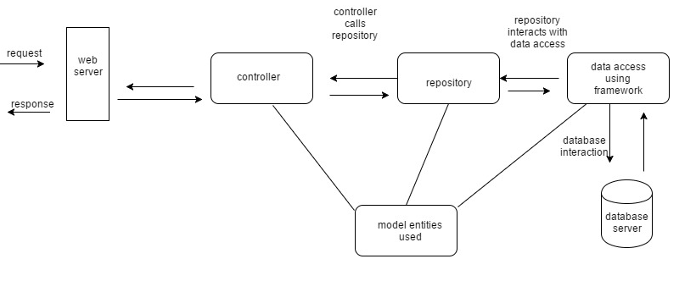

RESULTS
SCREEN SHOTS OF WORKING APPLICATION
Home Page

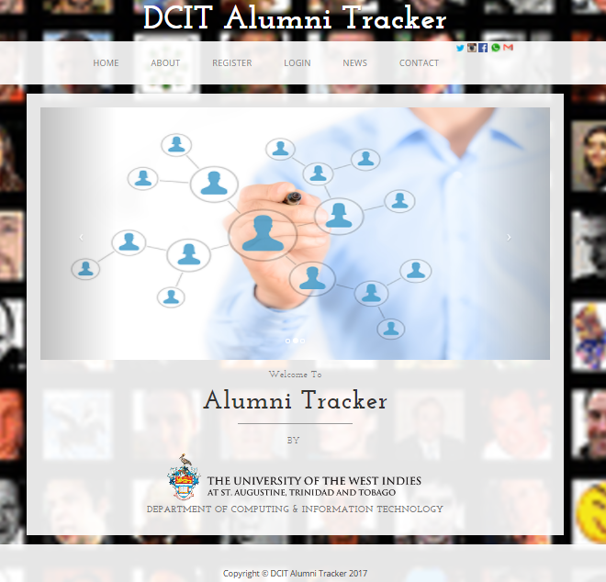

About Page
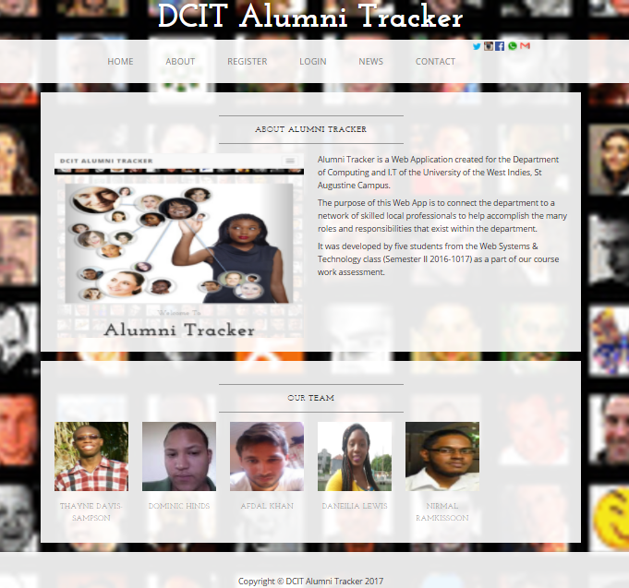

News page


Sign up Page
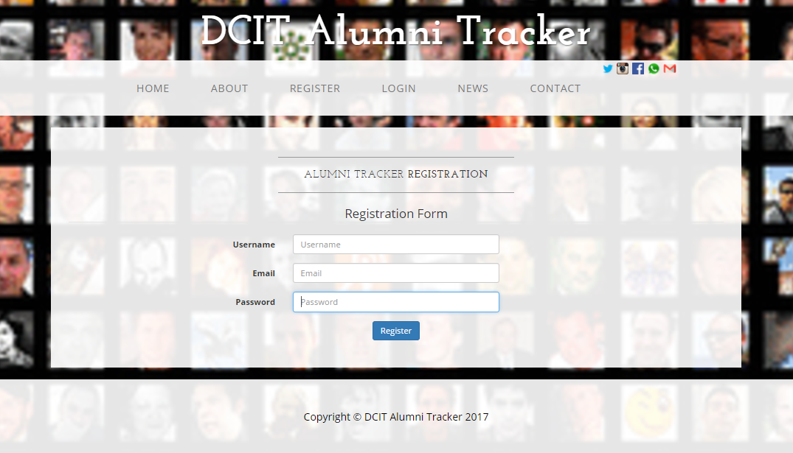

Login Page
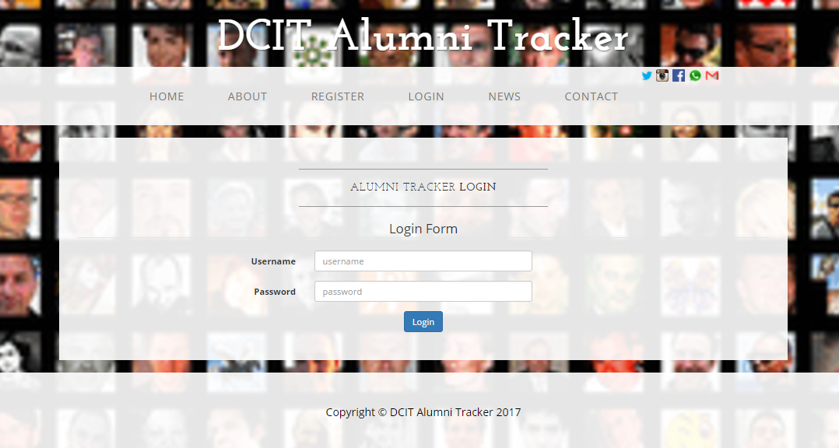

Contact Page
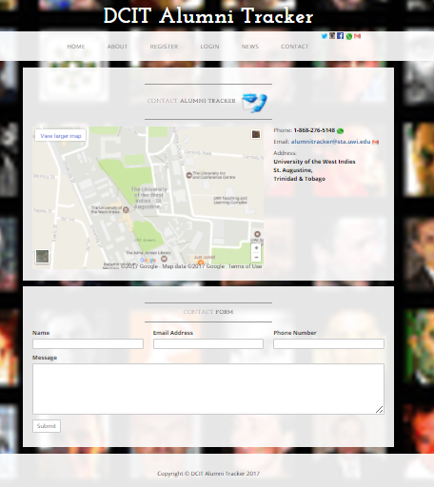

Page to update Profile Information
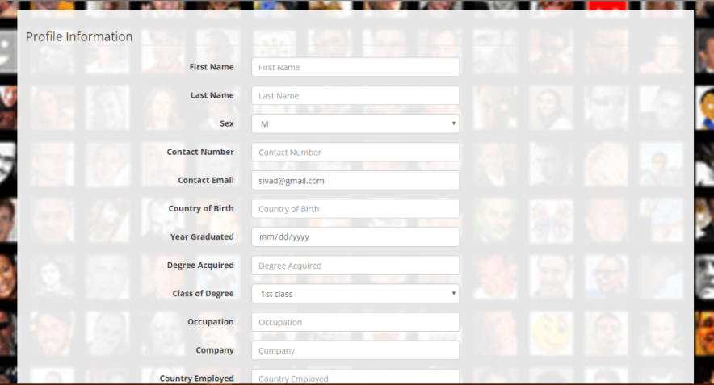

CONCLUSION & FUTURE WORK
There are a few things that can be implemented in the future to help improve the web application, they are :
- Implement an “Add friend feature” so that users can add other users they may know.
- Apply an instant messenger feature so that users can communicate with each other. Would also be useful for professionals to communicate and work on projects with each other.
- Implement a “search feature” so that users can find what they want faster instead of having to search through a list.
- As the website gets more popular more storage will be required.

